Lab 8

How a Neural Network Learns

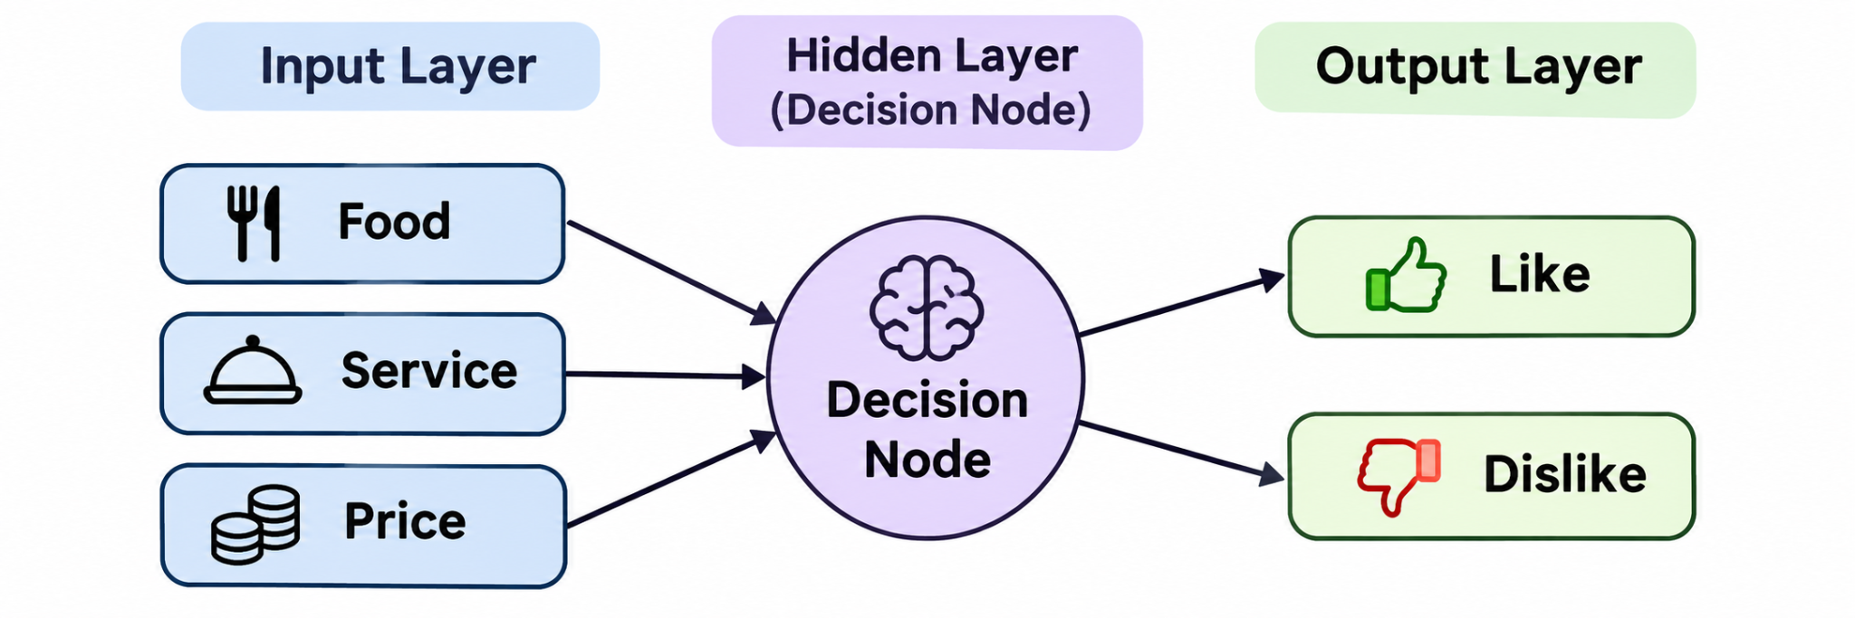

Part A — Training Phase
For this lab, I created a simple neural network to predict if a customer would like a restaurant or not.
I used three things: Food, Service, and Price. Since I worked alone, I did all the roles myself.
Starting Weights:
- Food: 1
- Service: 2
- Price: 1
I tested my network with 10 restaurant cards. I got 9 predictions correct and made one mistake on Card 9.
The customer liked the restaurant even though the service was bad. I realized that food should be more important, so I increased its weight.
Final Weights:
- Food: 2
- Service: 2
- Price: 1

Training Results
Card | Prediction | Actual Result | Correct?
1 | LIKE | LIKE | Yes
2 | DISLIKE | DISLIKE | Yes
3 | LIKE | LIKE | Yes
4 | DISLIKE | DISLIKE | Yes
5 | LIKE | LIKE | Yes
6 | DISLIKE | DISLIKE | Yes
7 | LIKE | LIKE | Yes
8 | DISLIKE | DISLIKE | Yes
9 | DISLIKE | LIKE | No
10 | DISLIKE | DISLIKE | Yes
Total Correct: 9/10
Training Accuracy: 90%

Part B — Testing Phase
After training, I tested my network with 3 new cards using the final weights.
Card | Prediction | Actual Result | Correct?
11 | LIKE | LIKE | Yes
12 | DISLIKE | DISLIKE | Yes
13 | LIKE | LIKE | Yes
All my predictions were correct.
Testing Accuracy: 100%

Training and Testing Comparison
My testing results were better than my training results. I got 90% during training and 100% during testing. This shows that my updated weights worked well on the three new cards, but I would need more cards to know how accurate my network really is.

Reflection Questions
1. How much did your predictions improve?
During training, I got 9 out of 10 correct. In the testing part, I got all 3 correct. My accuracy went from 90% to 100%.
2. How did weights help in learning?
Weights helped me understand which things were more important. When I made a mistake, I changed the weights to improve my next predictions.
3. What happens if we add more layers or inputs?
I think more layers and inputs could help the network make better predictions because it would have more information. But it would also make everything more complicated.
4. How does this reflect real AI learning?
Real AI learns in a similar way. It makes predictions, compares them with correct answers, and adjusts its weights. I learned that the network does not automatically know the correct answer. It needs training and feedback to improve.

Conclusion
This lab helped me understand how neural networks learn. I learned that weights are important because they affect the final decision.
I also understood that making mistakes is part of the learning process. By changing the weights, I was able to improve my predictions.

